“An Aggie does not lie cheat or steal, nor tolerate those who do”

1.

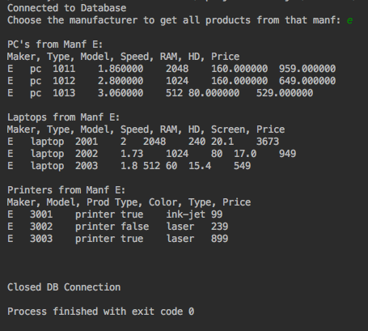

2.

